**Experiment 2.3**

**Student Name: Gaurav Kumar                                     UID: 22MCC20177**

**Branch: CC-DEVOPS Section/Group : 1/B**

**Semester: 1                                                                    Date of Performance: 01/12/2022**

**Subject Name : Python Programming                         Subject Code: 22CAH645**

1. **Write a program in Python to compute the greatest common divisor and the least common multiple of two integers.**

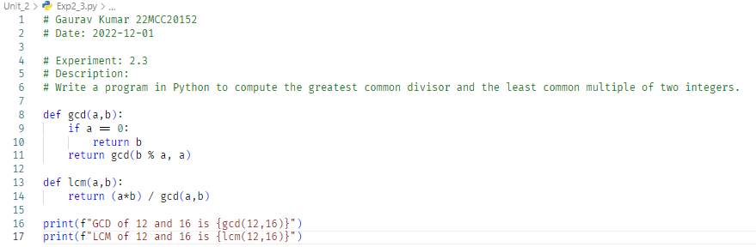

**Output (screenshots):**



1. **Write a program in Python to test if a number is equal to the sum of the cubes of its digits.Find the smallest and largest such numbers in the range of 100 to 1000.**

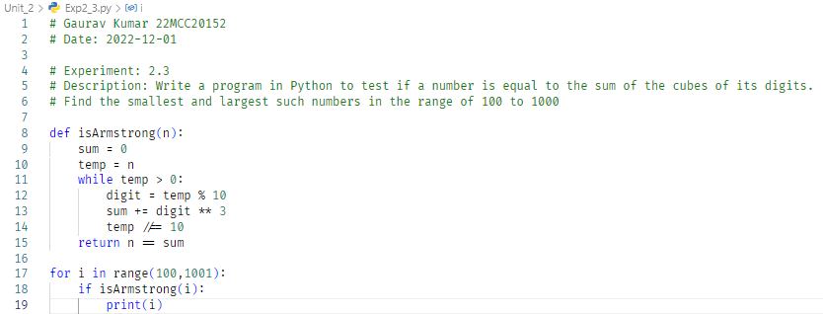

**Output (screenshots)**

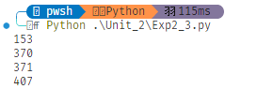

**4) Learning outcomes (What I have learnt): Times new roman 12 size**

**1. Learn about gcd and lcm.**

**2. Learn about Armstrong Numbers**

**3. Learn about recursive calls.**

**Evaluation Grid:**

|  |  |  |  |
| --- | --- | --- | --- |
| Sr. No. | Parameters | Marks Obtained | Maximum Marks |
| 1. | Demonstration and Performance  (Quiz) |  | 22 |
| 2. | Worksheet |  | 8 |